Year 10 Source Analysis Practice
What is the historical context of Source 1?
This document contains the type of questions you can be asked about primary and secondary sources. Read each question carefully as well as the notes on how to answer them. Then practice responding to the question in your notebook.

Historical context refers to the social, religious, economic, and political conditions that existed during a certain time and place

Type of source | Focus of source | Causes or Events that lead to the source | Specific details:  dates, events, people, places, or ideas
Photograph | The Great Depression | - World War I  - Treaty of Versailles  - Roaring 20’s (prosperity around the world)  - Wall Street Stock Market Crash  - High unemployment  - The Great Depression (extreme poverty) | 1929 Stock Market Crash  ‘Susso’- government handouts of money

Source Analysis Practice
What is the message of Source 2?

What is the source about? What is the author trying to say? Is he/she trying to make a particular point?
____________________________________________________________________________________________________________________________________________________________________________________________________________________________________________________________________________________________________________________________________________________________________________________

Weaknesses:
Strengths:
What are the strengths and weaknesses of Source 2?
Source Analysis Practice

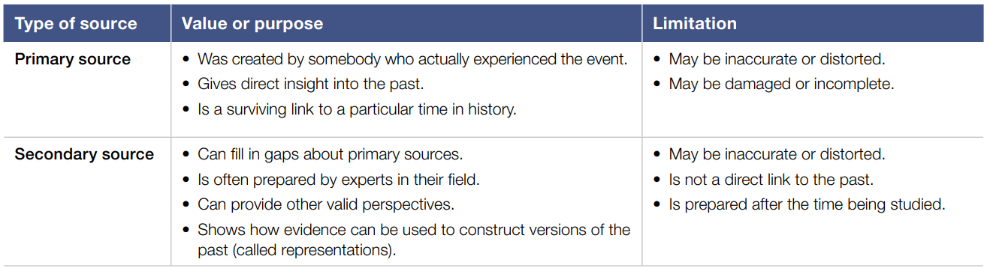
The source is useful because___, however, it is not useful because…
EVALUATE the USEFULNESS = assess the value of the source (how useful is the source and why)

Source Analysis Practice
Compare and contrast the messages of Source 3 and Source 4?
Source A | Source B
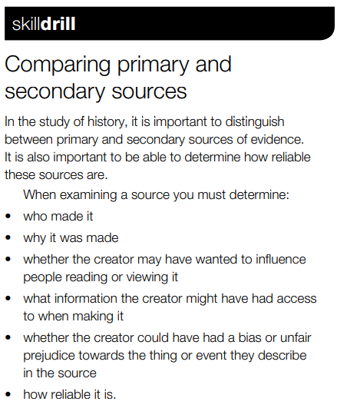
For each source:
- Look closely and consider the source
- Identify what message the source is communicating to the audience (What is the author's message or argument? What was he/she trying to get across?)
Then, in your response, write:
- The message of source one
- Write how source one communicates this message (techniques such as language, symbols, size of characters, etc.) and provide evidence of this
- Repeat the above two steps for source two
- Discuss how the messages are similar (compare)
- Discuss how the messages are different (contrast)

Response:

Source 3 is similar to Source 4 because…
Source 3 and Source 4 are different because…

